DAD 220 Project Two: Analyzing Databases

To begin working on the database, I need to ensure that the appropriate database is selected by using the USE command. After setting the database to QuantigrationUpdates, the following commands will be executed to gather relevant data for analysis.  
  
SELECT COUNT(\*), Collaborator.State

FROM RMA

INNER JOIN Orders ON RMA.OrderID = Orders.OrderID

INNER JOIN Collaborator ON Orders.CustomerID = Collaborator.CustomerID

GROUP BY Collaborator.State;  
  
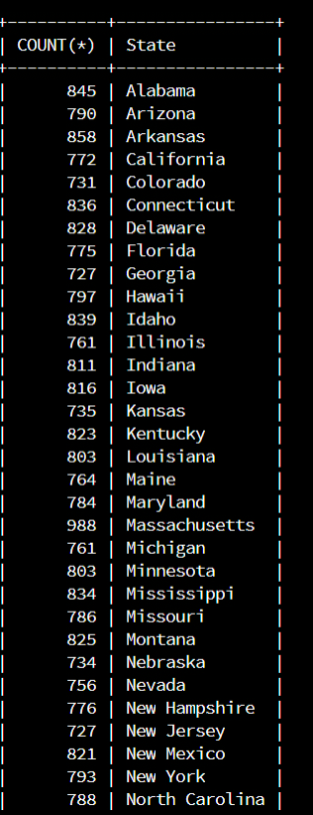

This step involved using a SQL command to determine the total number of returns per state. The analysis revealed that South Carolina had the lowest number of returns, with only 715, while Massachusetts had the highest number of returns, with 988.

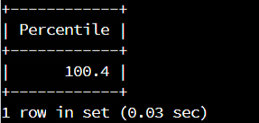  
  
SELECT ROUND(100 \* R.RT / (SELECT COUNT(\*) FROM Orders), 1) AS Percentile

FROM Orders

CROSS JOIN (

SELECT COUNT(\*) AS RT

FROM RMA

) AS R

LIMIT 1;  
  
To determine the percentage of returns by state, I used a SQL command to calculate the ratio of returns to orders for each state. Based on my analysis, it appears that the return rate was consistent across all states at approximately 100.4%

Analysis:

This information, when combined with data from previous weeks, can help a product manager understand the extent of returns and the severity of the situation by state. It can also assist in identifying specific product issues if there were to be more variations. However, since this is an example dataset, the information may not be entirely useful due to the uniformity of the data. In a real-world scenario, it would be more helpful to use SKU/Product name to identify specific item RMA trends instead of just state.

After analyzing historical RMA data, we found that there was a 98.5% return rate across all products and states. To address this issue, the company could consider procuring a different product that has fewer faults or taking steps to reduce the chance of RMAs by strengthening the devices. Alternatively, the company may need to consider adopting an "All sales are final" approach if neither of these options is deemed feasible.